There may be circumstances requiring the manual conferring of a degree. This may occur when a student earns a certificate or other situations. This requires two steps:
- Confer the program
- Edit Program of Study for Student Task (requires security access)

Use this reference to confer a degree.

INSTRUCTIONS:

STEP ONE: Confer the program
- Look up the student’s record in Workday.

- Go to the Actions button. Select Academic Record. Select Complete Programs.
Note: Alternatively you can go to the task: Complete Programs for Student by searching it in the search bar.
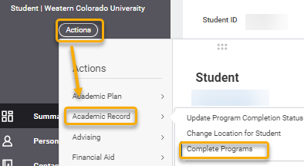

Note: If you want to update the program completion status, use the Update Program Complete Status task to manually change the completion status to Applied for Completion or Approved for Completion, for example.
Program Completion Status is separate from the Program of Study Status (eg. In Progress, Pending Completion). The Program Completion Status is like a sub-status of the Program of Study “Pending Completion” status. While the Program Completion Status may be “Applied for Completion” or “Approved for Completion”, the Program of Study Status will remain “Pending Completion” until graduation.
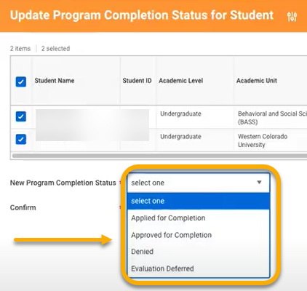
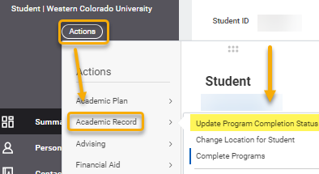

- Click “OK” to select the student.
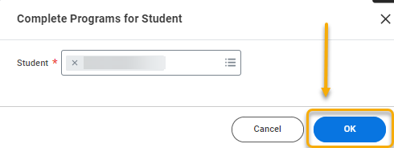

- Check the box(es) corresponding to the programs to confer.

- In the Academic Period for Completion field, enter the academic period in which they are graduating.

The Conferral Date will auto-populate a date from the date controls.

If the conferral date does not populate, or is incorrect, click Override Conferral Date from Period Date Controls to enter correct date.

- Click the Confirm box and click “OK”.
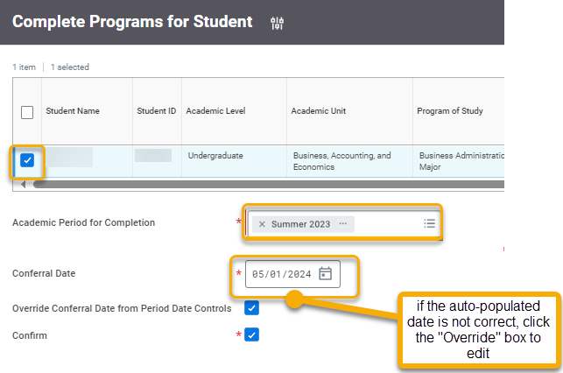
STEP TWO: Edit Program of Study for Student Task
- The Complete Programs for Student page will appear with a conferral date at the bottom of the table. This date tends to lead to bad data on the Program of Study Status Effective Date. To correct, an administrator with security status must follow these steps:
In the search bar, type and select the “Edit Program of Study for Student” task.
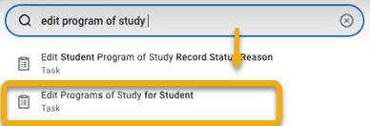
- In the Edit Program of Study for Student window, enter and select the student. The academic record will auto-populate.

- Click “OK”.

- The Edit Program of Study for Student task page will display. Draw your attention to the columns labelled Effective Date, Program of Study, and Status.

Locate the program(s) of study for which you are conferring the degree. At this point, it should have Completed in the Status column.

- Locate the Effective Date column and change to the end of term.
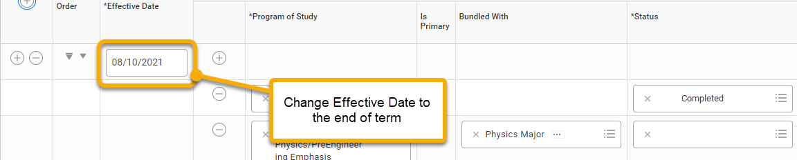

- Click “OK”.

